Supply Chain Costing (SCC)
SCC is a specialised area of costing and most organizations have a need to better understand their supply chain costs, yet few attempt to do this. Supply chain costs are major costs in serving customers and needs to be understood to accurately measure “Cost-to-Serve”.
In the previous century most organisations focused cost reduction efforts at the cost of making products or producing services. In many cases nowadays, limited scope exists for reengineering costs in the manufacturing processes and many organisations have now focussed the attention in reducing costs in the Supply Chain. They understand the opportunities that exist in streamlining the supply chain and reducing cost-to-serve to customers but find it hard to get a grip on this elusive concept of supply chain costs and determining cost-to-serve.
This is partly due to the complexities that exists in modern supply c hains and the literally millions of permutations that exists when having to deal with these costs. Just think of a company that has a few factories, a handful of distribution centers, different marketing channels and serving a couple hundred customers. Even though this is not a very complex organization, many millions of cost permutation s may exist to deliver specific products to specific customers and determine an accurate cost-to-serve. This complexity can easily be seen from the conceptual diagram below.
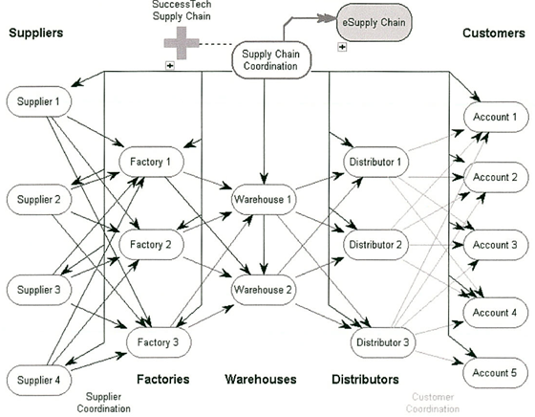
Resolving the Cost-to-Serve cost dynamics requires special technology and methodologies as the normal costing models will not provide accurate answers. There is no point in calculating “average” cost of Transport or Warehousing if the costs cannot be related to the customer. Conventional activity-based costing models are good in process based industries where goods are made in a repetitive fashion, unlike the Supply Chain where goods can be shipped from any number of distribution centres, thru different marketing channels, using different forms of transport in different configurations for every order.
SCC requires technologies that can handle these millions of permutations and complexities yet can produce effective answers for identifying opportunities for cost reduction. Cortell uses a combination of its Valumax costing system and OLAP models to measurecost in cost supply chains. This methodology has evolved thru multiple supply chain costing studies and Cortell can now offer this unique approach to organizations that wish to measure Cost-to-Serve, even in the most complex environments.
Contact us today for a demo or discussion of how we can assist your organization to measure supply chain costs.

